PRESENTING CLINICAL SIGNS
History: Hypoglycemic seizure. Previous history of cardiomegaly.
Physical Examination: N/A.
Urinalysis: N/A
CBC: N/A.
Serum Biochemistry: N/A.
Radiographic Findings: N/A.

ULTRASONOGRAPHIC EXAMINATION OF THE ABDOMEN
Urinary System
Full urinary bladder with a normal thickness and echogenic appearance of the wall. Normal anechoic urine with no sediment or uroliths evident.
Normal trigone area, proximal urethra (0.3 cm), and iliac blood vessels.
Normal iliac lymph nodes (1 cm). Ureters not visualized.
Normal renal size (left 3.6 cm, right 4.1 cm), echogenic appearance, cortico-medullary differentiation, pelvis, and capsule.
Reproductive System
Normal appearance of the uterus and ovaries.
Adrenal Glands
Normal position, echogenic appearance, shape, and size. Left 0.65/0.48 cm, right 0.59/0.4 cm.
Spleen
Normal size (0.9 cm) and echogenic appearance. Smooth homogenous parenchyma, regular curvilinear capsule, and normal vasculature. No evidence of inflammatory, neoplastic, infarction, or infiltrative changes noted.
Liver
Normal size with a diffuse mottled echogenic and nodular appearance, loss of portal markings, and regular curvilinear capsule. Nodules are hypoechogenic, parenchymal, and up to 0.7 cm in size No masses evident. Full gall bladder containing normal anechoic bile. Normal thickness and echogenic appearance of the gall bladder wall. Normal bile duct (0.2 cm).
Gastrointestinal
Normal appearance of the stomach, duodenum, small intestine, ileo-cecal junction, and colon with no loss of layering, normal wall thickness (stomach 0.38 cm, duodenum 0.4 cm, jejunum 0.3 cm, colon 0.16 cm) and peristaltic activity, and no distension of the lumen. Mucosal stippling within the small intestine. Large amount of ingesta and chyle in the stomach and small intestine, respectively.
Pancreas
Normal size (left 0.8 cm, right 1 cm) and echogenic appearance. Regular capsule. Two hypoechogenic parenchymal nodules (0.9 x 1 cm, 0.3 cm) in the right lobe. Normal echogenic appearance of the mesentery and fat surrounding the pancreas.
Free Abdomen
Normal mesenteric lymph nodes (0.7 cm).
No ascites.

ULTRASONOGRAPHIC FINDINGS
Primary Findings:
- Pancreatic nodules.
- Nodular hepatopathy.
Secondary Findings:
- Intestinal mucosal stippling.

INTERPRETATION OF THE FINDINGS & FURTHER RECOMMENDATIONS
With the hypoglycemia, an important etiology for the pancreatitic nodules would be insulinoma; with pancreatitis, granulomas, and abscessation differential diagnoses.
Etiologies for the nodular hepatopathy would be reactive, nodular regeneration, chronic hepatitis, granulomatous disease, and neoplasia.
Although the mucosal stippling can most likely be ascribed to the ingesta/chyle within the GI tract rather than to lymphangectasia (primary or secondary), if should be followed up with an ultrasound after fasting.
Further assessment would be cPL/PSL assay, insulin assay (in conjunction with blood glucose), and FNA cytology of the liver and pancreatic nodules.
Specific therapy would be dependent on an etiological diagnosis.

IMAGES
Liver
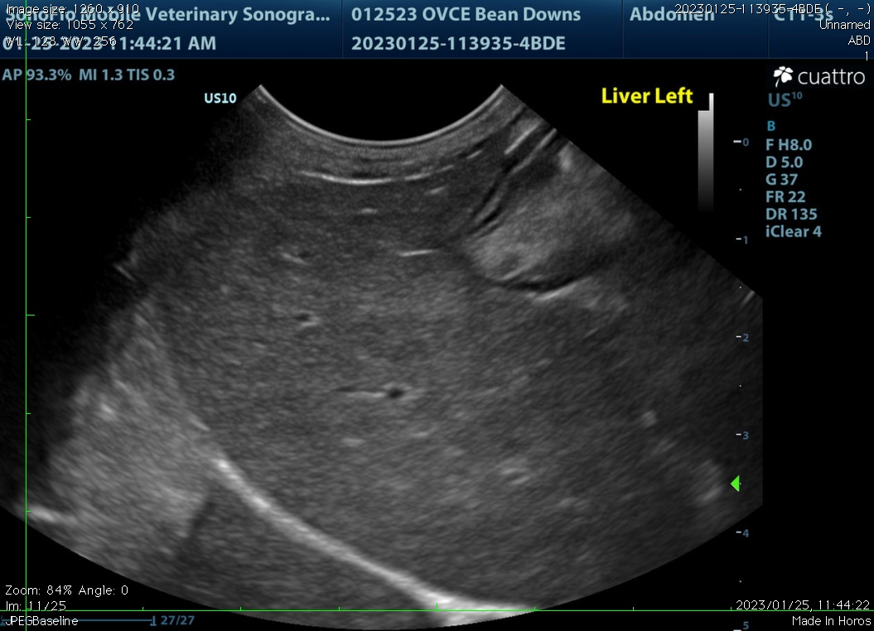
Pancreas
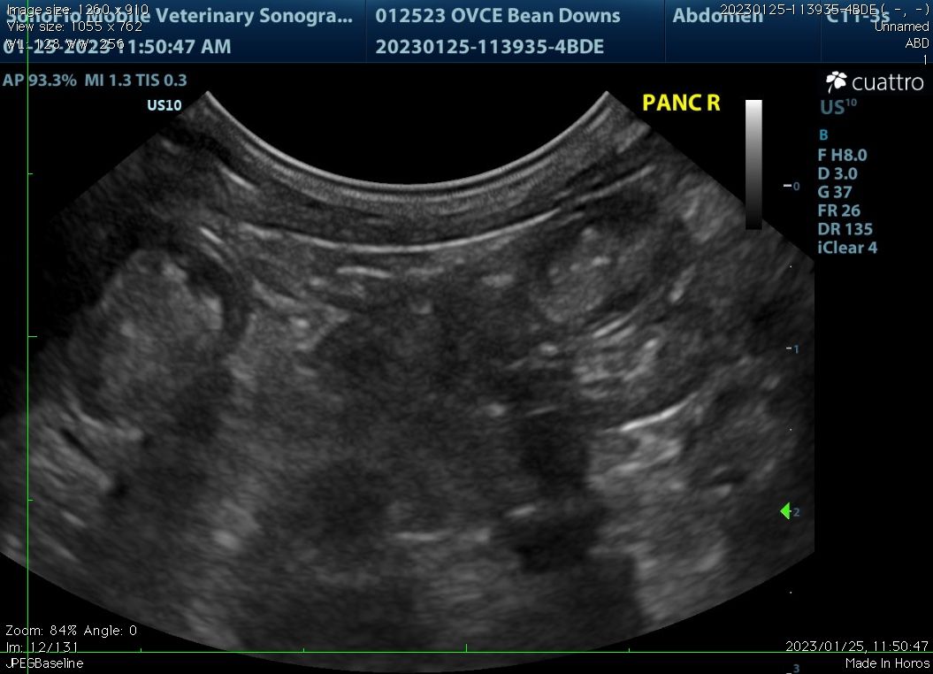
The information and recommendations provided are based on the images presented by the referring veterinarian. No evaluation can be communicated regarding pathology that was not visible in the image/video clips provided.

Thank you for this referral. If the clinical or image interpretation does not parallel your findings or if I can be of any further assistance, please contact me.

Remo Lobetti, BVSc, MMedVet (Med), PhD, Dipl. ECVIM (Internal Medicine)
rlobetti@mweb.co.za

